Genotyping on C9orf B Colony.

Long Range PCR
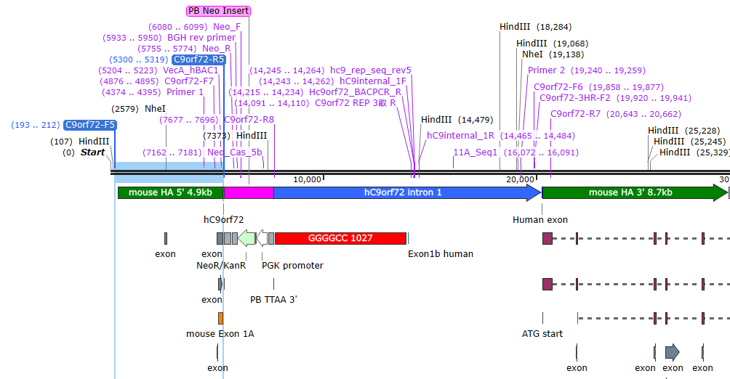
C9orf72-F5 TCGGGATGAAGAGGCAGGTA 5127bp
C9orf72-R5 CTTGTTCACCCTCAGCGAGT

M0323S |  | 25ul | 20ul | Master
LongAmp Buffer | 5x | 5 | 4 | 20
Primer F | 10uM | 1 | 0.8 | 4
Primer R | 10uM | 1 | 0.8 | 4
dNTPS | 8mM | 0.75 | 0.6 | 3
LongAmp Taq |  | 0.5 | 0.4 | 2
dH2O |  | 16.75 | 13.4 | 67
No of Samples | 3
Positive Control | 0
Negative Control | 0
Water Control | 1
 | 4

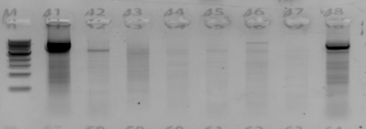
Clone selected for micro-injection

Identifying Short & Long Humanizations

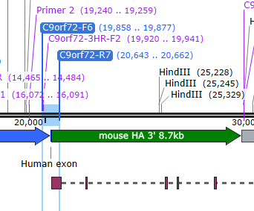
C9orf72-F6 gggttaggggccaaatctcc (805bp)
C9orf72-3HR-F2 tgcgggtctattctatgagctt (743bp)
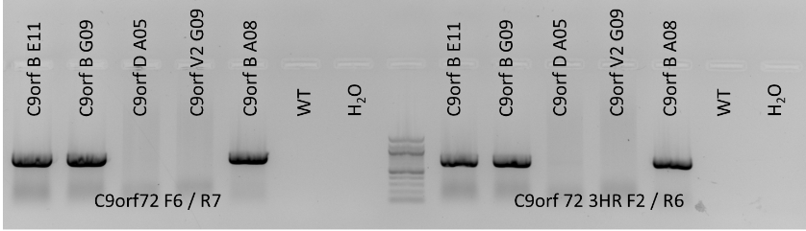
C9orf72-R7 TGGGAGGTAGAAGCTCAGCT (doesn’t bind in the LH)
Taq = Bio-21047 | 50ul | 20ul | Master
10X buffer | 5 | 2 | 16
MgCl2 | 1.5 | 0.6 | 4.8
Fwd Primer | 2.5 | 1 | 8
Rev Primer | 2.5 | 1 | 8
dNTPS | 1 | 0.4 | 3.2
Immolase | 0.25 | 0.1 | 0.8
Q solution | 10 | 4 | 32
DNA | 2.5 | 1
Water | 24.75 | 9.9 | 79.2
No of Samples | 4
Positive Control | 1
Negative Control | 1
Water Control | 1
Total Samples | 7

Short PCR to confirm GLT

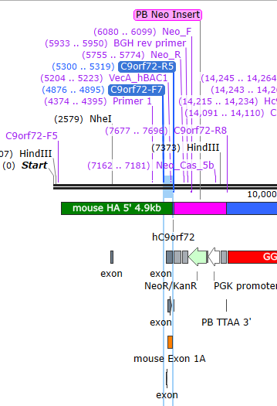
C9orf72-F5 TCGGGATGAAGAGGCAGGTA
C9orf72-R7 TGGGAGGTAGAAGCTCAGCT
Taq = Bio-21047 | 50ul | 20ul | Master
10X buffer | 5 | 2 | 34
MgCl2 | 1.5 | 0.6 | 10.2
Fwd Primer | 2.5 | 1 | 17
Rev Primer | 2.5 | 1 | 17
dNTPS | 1 | 0.4 | 6.8
Immolase | 0.25 | 0.1 | 1.7
Q solution | 10 | 4 | 68
DNA | 2.5 | 1
Water | 24.75 | 9.9 | 168.3
No of Samples | 12
Positive Control | 2
Negative Control | 1
Water Control | 1
Total Samples | 16
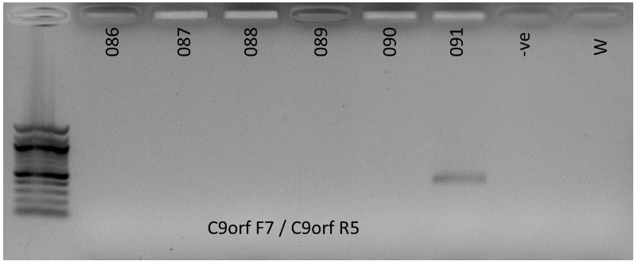

Tail Snip obtained for 091, and repeat
PCR performed for confirmation.
