Full C9orf Genotyping

PCR for GLT
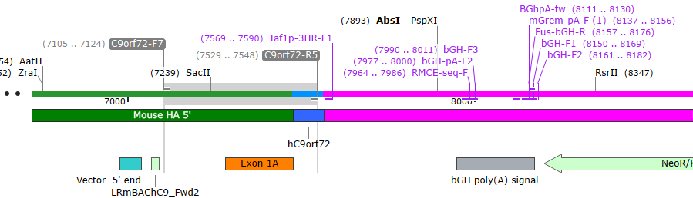
C9orf72-F7 | CTGAGCGGCTCTTGGAAGAA
C9orf72-R5 | CTTGTTCACCCTCAGCGAGT
Run on 2% Agarose gel

PCR Program.

Reaction Mix |  |  | Reaction conditions
genomic Mouse DNA | 20-100 | ng | Step | Temp. | Time | Cycles
Primers | 10 | pmol | Denaturing | 94°C | 300s | 1x
dNTPs | 0.16 | mM | Denaturing | 94°C | 30s
10 x Reaction Buffer | 0.1 | Vol | Annealing | 60°C | 30s | 32x
Q solution (5M Betaine) | 0.2 | Vol | Extension | 72°C | 45s
MgCl₂ | 3 | mM | Completion | 72°C | 420s | 1x
Taq Polymerase (Immolase) | 1.0 | U |  | 12°C | -
Reaction Volume | 20.0 | µl

Taq = Meridian Bioscience IMMOLASE DNA Polymerase - 500 Units
Code: BIO21047
dNTPS = Meridian Bioscience dNTP Set 100mM - 4 x 25umol (4 x 250uL)
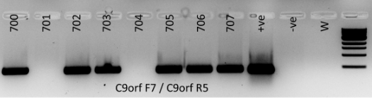
Code: BIO39025

PCR for GLT

PGK-F1 TACCGGTGGATGTGGAATGTG
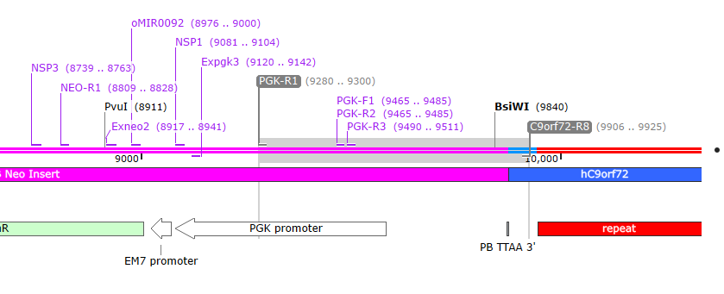
C9orf72-R8 TTCCAGAGCTTGCTACAGGC

PCR Program.

Reaction Mix |  |  | Reaction conditions
genomic Mouse DNA | 20-100 | ng | Step | Temp. | Time | Cycles
Primers | 10 | pmol | Denaturing | 94°C | 300s | 1x
dNTPs | 0.16 | mM | Denaturing | 94°C | 30s
10 x Reaction Buffer | 0.1 | Vol | Annealing | 60°C | 90s | 32x
Q solution (5M Betaine) | 0.2 | Vol | Extension | 72°C | 45s
MgCl₂ | 3 | mM | Completion | 72°C | 420s | 1x
Taq Polymerase (Immolase) | 1.0 | U |  | 12°C | -
Reaction Volume | 20.0 | µl

Taq = Meridian Bioscience IMMOLASE DNA Polymerase - 500 Units Code: BIO21047
dNTPS = Meridian Bioscience dNTP Set 100mM - 4 x 25umol (4 x 250uL) Code: BIO39025
